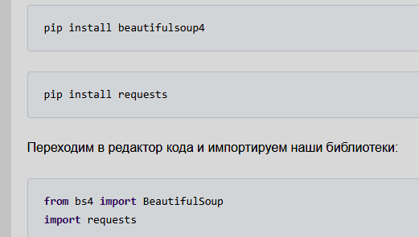

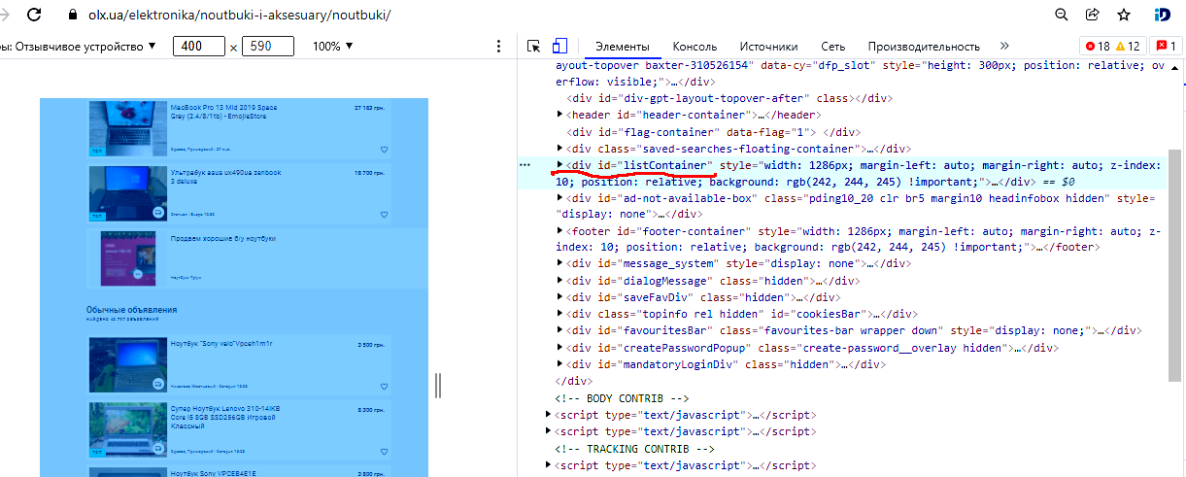

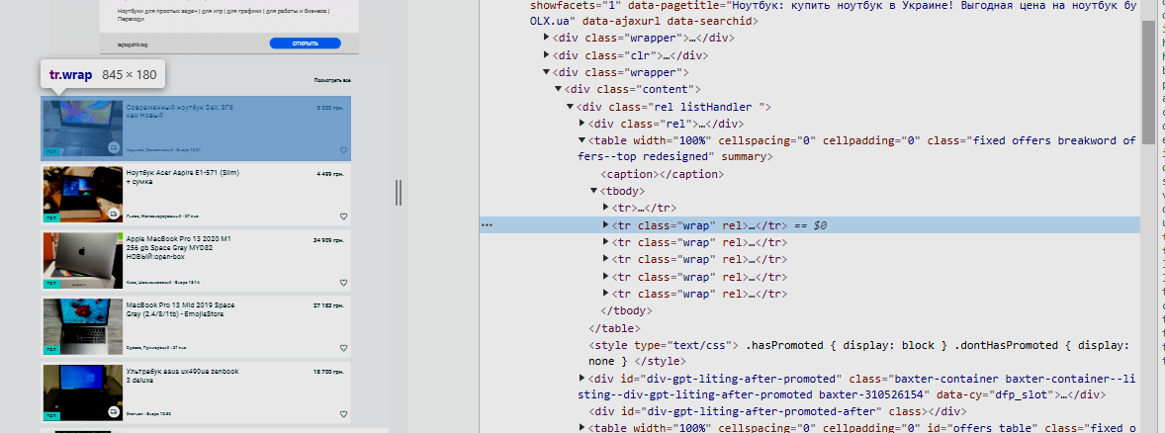

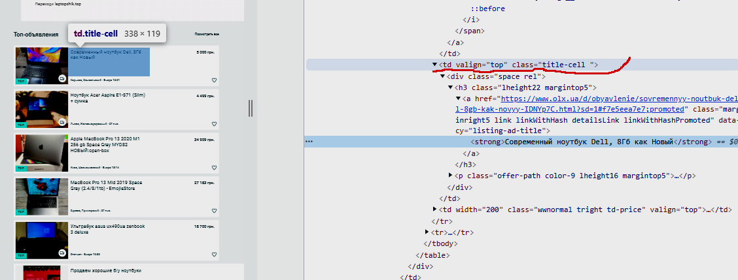

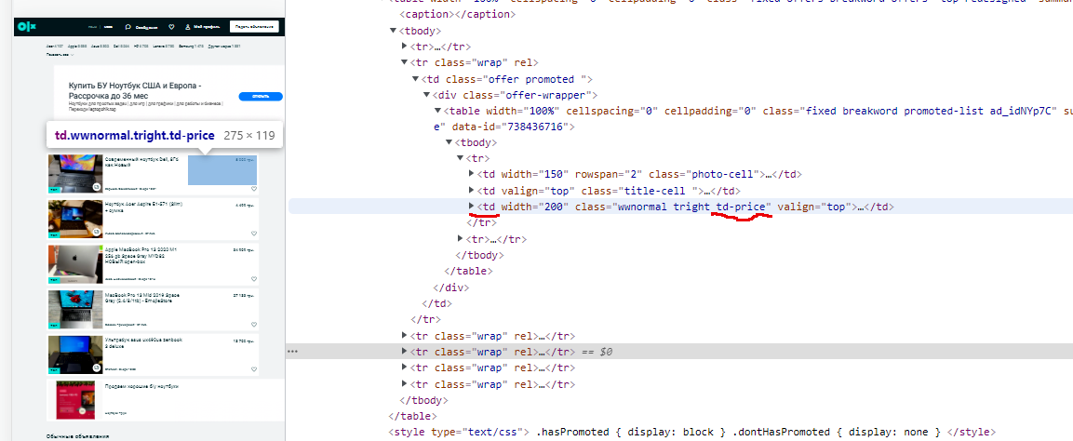

########################################################################
#### NEWS ######################################################################
url = 'http://mignews.com/mobile'
page = requests.get(url)
print(page.status_code)
filteredNews = {}
soup = BS(page.text, "html.parser")
allNews = soup.findAll('div', class_='text-color-dark')
for data in allNews:
filteredNews[data.text.replace('\n', '')] = data.a['href']
print('=' * 80)
for key, vol in filteredNews.items():
print(key)
print(vol)
print('=' * 80)

url = 'https://www.pravda.com.ua/'
page = requests.get(url)
print(page.status_code)
soup = BS(page.text, "html.parser")
allNews = soup.findAll('div', class_="article_header")
# print(allNews)
for data in allNews:
filteredNews[data.text.replace('\n', '')] = data.a['href']
print('=' * 80)
for key, vol in filteredNews.items():
print(key)
print(vol)
print('=' * 80)

url ='https://sport.ua/uk'
page = requests.get(url)
print(page.status_code)
soup = BS(page.text, "html.parser")
news = soup.findAll('div', class_="main-news__item")
print(news)
for data in news:
text = data.img['alt']
href = data.a['href']
print(text)
print(href)
print('='*80)

url = 'https://www.bbc.com/ukrainian'
page = requests.get(url)
print(page.status_code)
soup = BS(page.text, "html.parser")
allNews = soup.find_all('div', attrs={'dir': 'ltr'})
print(allNews)
for el in allNews:
pr = el.find_all('span')
for i in pr:
print(i.text)
print('='*80)

